

KISII SCHOOL 2025 PREDICTION
(KCSE PRE-ANALYSIS TEST)
121/1
MATHEMATICS
PAPER 1
TIME: 2½ HOURS

NAME……………………………………………………………………………………….
SCHOOL……………………………………………… SIGN………………………..
INDEX NO……………………………………………. ADM NO……………………

(Kenya Certificate of Secondary Education)

INSTRUCTIONS TO CANDIDATES
- Write your name, index number and class in the spaces provided above.
- The paper contains two sections: Section I and Section II.
- Answer ALL the questions in Section I and ANY FIVE questions from Section II.
- All working and answers must be written on the question paper in the spaces provided below each question.
- Marks may be awarded for correct working even if the answer is wrong.
- Negligent and slovenly work will be penalized.
- Non-programmable silent electronic calculators and mathematical tables are allowed for use.

For examiners use only
Section I
1 | 2 | 3 | 4 | 5 | 6 | 7 | 8 | 9 | 10 | 11 | 12 | 13 | 14 | 15 | 16 | Total

Section II
Grand
Total
17 | 18 | 19 | 20 | 21 | 22 | 23 | 24 | Total

SECTION I (50 MARKS)
Attempt All Questions in this section
1. Find the value of y given that (3 marks)

2. The length of a minute hand of a clock is 3.5cm. What will be the time if from 10.15am it sweeps through an area of 19.25cm²? (4marks)

3. Use reciprocal, square and square root table to evaluate to 4 significant figures, the expression
(3marks)

4. Given that sin (90-x)⁰ =0.8, where x is an acute angle, find without using mathematical table the value of 2 tan x+cos(90-x) (3marks)

5. Find the equation of the tangent and the normal to the curve at the point (2,10) (4marks)

6. Simplify (3marks)

7. Find greatest integral value of x which satisfies
(3marks)

8. One of the roots of the equation is 4. Find the values of k and hence the second root (4marks)

9. Solve for x in the following without using a calculator or mathematical table.
(3marks)

10.A shear parallel to the x-axis maps point (1, 2) onto a point (5, 2). Determine the shear factors and hence state the shear matrix (invariant line is y=0) (3marks)

11.A solid is in the shape of a right pyramid on a square base on side 8cm and height 15cm. A frustum whose volume is a third of the pyramid is cut off. Determine the height of the frustum. (3 marks)

12.The interior angle of a regular polygon is 20º more than three times the exterior angle. Determine the number of sides of the polygon (2marks)

13.Three fifths of work is done on the first day. On the second day of the remainder is completed. If the third day of what remained id done, what fraction of work still remain to be done. (3marks)

14.A two-digit number is such that the sum of the digits is ten. If the digits are reversed, the new number formed is less than the original number by 18. Find the number (3marks)

15. In the figure bellow, CBD= 2CAD. Find the value of x (3marks)
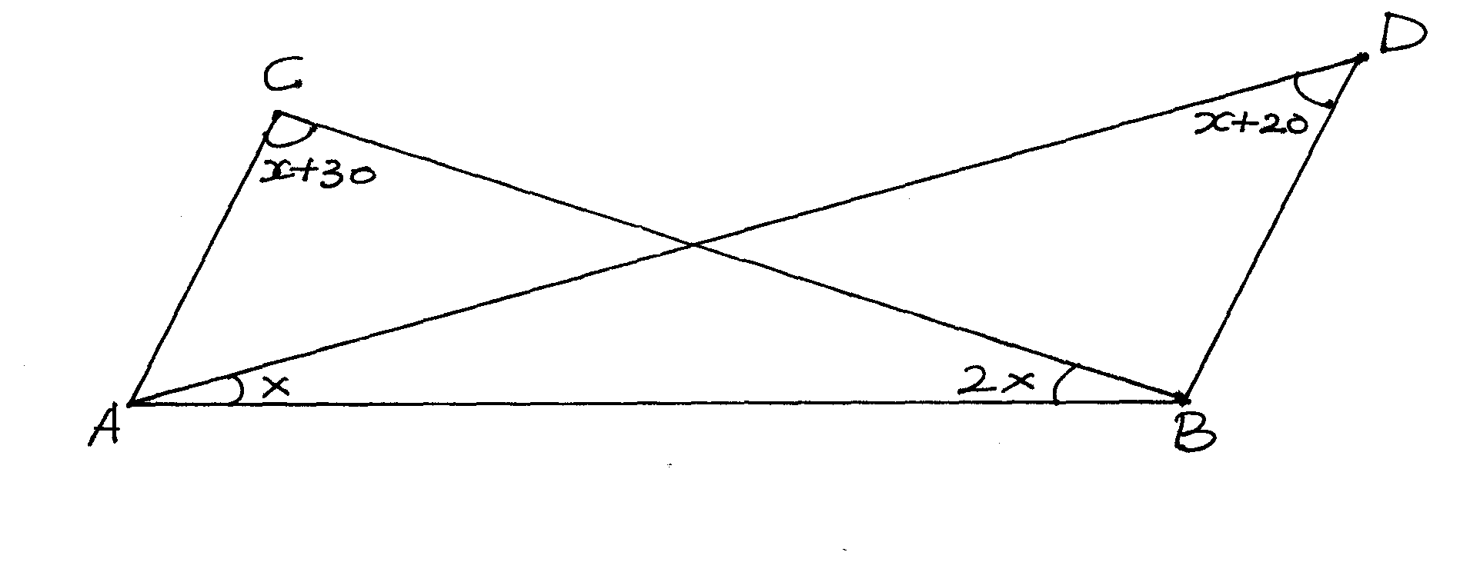

16.Two boys, Ababu and Chungwa, on the same side of a tall building are 100m apart. The building and the two boys are in a straight line and the angles of elevation from the boys to the top of the building are 30º and 20º respectively calculate the height of the building.(3marks)

SECTION II (50 MARKS)
Attempt only five Questions from this section
17.A business lady bought 100 quails and 80 rabbits for sh25600. If she had bought twice as many rabbits as half as many quails she would have paid sh7400 less. She sold each quail at a profit of 10% and each rabbit at a profit of 20%.
a) Form two equations to show how much she bought the quails and the rabbits. (2marks)

b) Using matrix method, find the cost of each animal. (5mrks)

c) Calculate the total percentage profit she made from sale of the 100 quails and 80 rabbits. (3marks)

18.A(3,7) B(5,5), C(3,1), D(1,5) are vertices of a quadrilateral
a) On the grid provided below, plot ABCD on a Cartesian plan (2marks)

b) A¹B¹C¹D¹ is the image of ABCD under a translation T plot A¹B¹C¹D¹and state its coordinates (2marks)

c) Plot A¹¹B¹¹C¹¹D¹¹ the image of A¹B¹C¹D¹ after a rotation about (-1,0) through a positive quarter turn. State its coordinates. (3marks)

d) A¹¹¹B¹¹¹C¹¹¹D¹¹¹ is the image of A¹¹B¹¹C¹¹D¹¹ after a reflection in the line y=x+2. Plot A¹¹¹B¹¹¹C¹¹¹D¹¹¹ and state its coordinates (3marks)
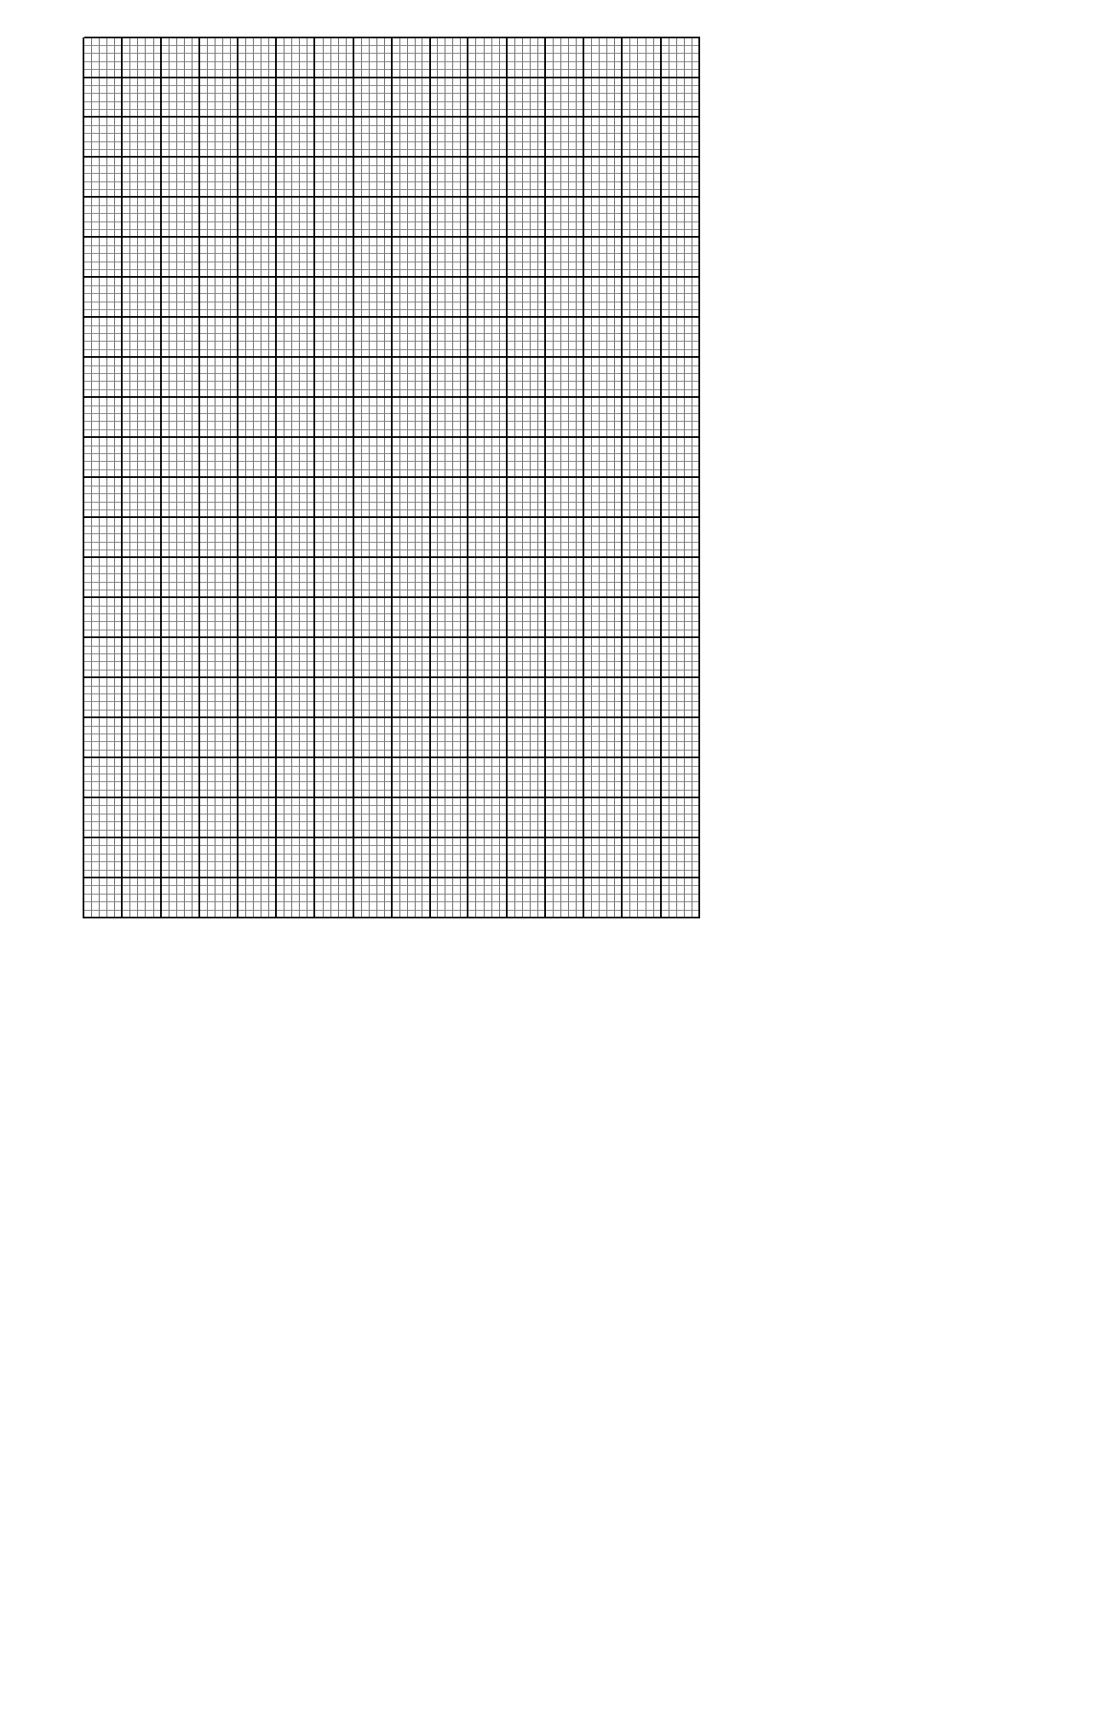

19.The figure below shows a velocity time graph of a journey of a car. The car start from rest and accelerates at for t seconds until it is 22m/s
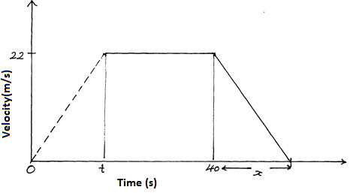
Brakes are applied bringing it uniformly to rest. The total journey is 847m long. Find.
a) The value of t, the acceleration time (2marks)

b) The distance travelled during the first t seconds. (2marks)

c) The value of x, the deceleration time (4marks)

d) The rate of deceleration (2marks)

20.The diagram below shows a histogram representing the mass of some pupil in a school.
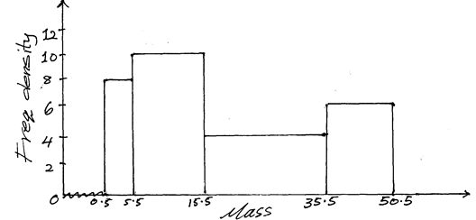
a) Prepare a frequency distribution table of the data (3marks)

b) From the table above, estimate
i) The mean mass of the pupils to 3 s.f (3marks)

ii) The median mass (3marks)

iii) How many pupils were 40kg and above (1marks)

21.In the figure below OY:YA=1:3 AX:XB=1:2 OA= and OB= . N is the point of intersection of BY and OX
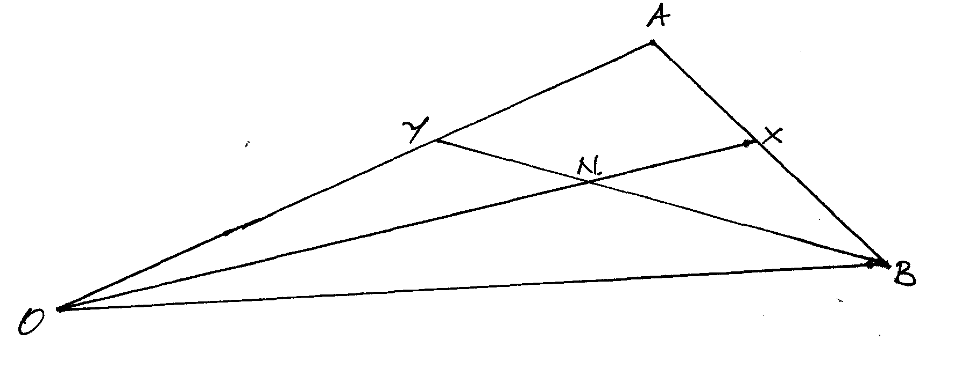
a) Determine
i) OX (2marks)

ii) BY (1mark)

b) Give that and ON=hOX, express in two ways in terms of (3marks)

c) Find the value of h and k and hence show that O,N and X are collinear (4marks)

22.Using a ruler and a pair of compass only, construct triangle XYZ where XY is 6cm and XYZ is 135º and YZ=7cm (2marks)

a) Measure XZ (1mark)
b) Drop a perpendicular from Z to meet line XY at K , measure ZK. (2marks)
c) Bisect line XY and let the bisector meet line XZ at Q (1mark)
d) Join Q to Y and measure angle XQY (2marks)
e) Find the area of triangle XYZ (2marks)

23.Four towns are situated in such that a way that town Q is 500km on a bearing of 120º from P. Town R is 240 km on a bearing of 210º from town P, while town S is due north of town Q and due east of town P
a) Draw a sketch diagram showing the relative position of P,Q,R and S (scale:1cm :100km) (3marks)

b) Find by calculation
i) The distance QR (1mark)

ii) The distance QS (2marks)

iii) The angle PRSQ (2marks)

iv) The area of triangle PQS (2marks)

24.The figure below shows a sketch of the graph of .
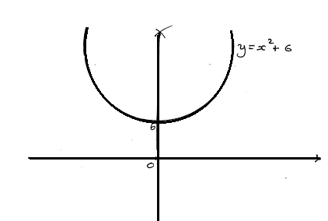
a) Estimate the area bounded by the curve, the x-axis and the line x =-4 and x=4 using
i) The trapezium rule with 8 sides (3marks)

ii) The mid- ordinates rule with and strips (3marks)

b) What percentage error is caused by estimating the area of the curve using the mid ordinates rule as in a (ii) above (4marks)

THIS IS THE LAST PRINTED PAGE

